1. **Total number of patient**

SELECT

Count (patient_id) as total_mumbers_of_patients

FROM [Hospital ER]

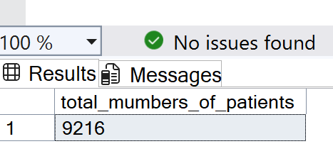

1. **Avg patients age**

SELECT

AVG (patient_age)

FROM [Hospital ER]

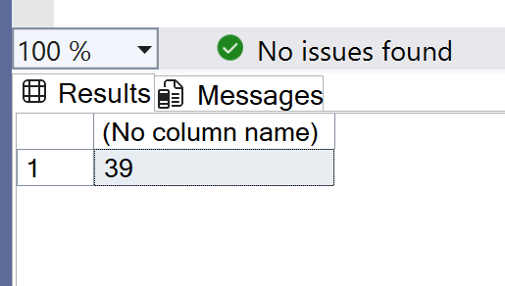

1. **Total patient by gender**

SELECT

patient_gender,

COUNT(patient_id) AS GenderCount

FROM [Hospital ER]

GROUP BY patient_gender;

;

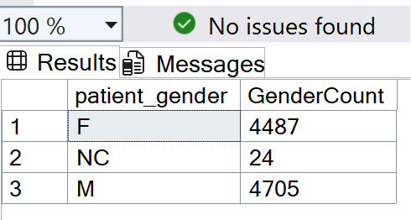

1. **Total number of patients by race**

SELECT

s AS Race,

COUNT(patient_id) AS patient_count

FROM [Hospital ER]

GROUP BY s

ORDER BY patient_count DESC;

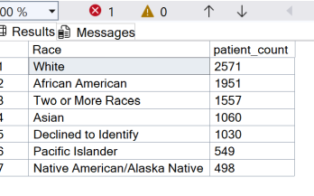

1. **Total patient by age group**

SELECT

CASE

WHEN patient_age BETWEEN 0 AND 1 THEN 'Infant (Baby)'

WHEN patient_age BETWEEN 2 AND 4 THEN 'Young Child'

WHEN patient_age BETWEEN 5 AND 9 THEN 'Child'

WHEN patient_age BETWEEN 10 AND 19 THEN 'Adolescent'

WHEN patient_age BETWEEN 20 AND 24 THEN 'Youth'

WHEN patient_age BETWEEN 25 AND 59 THEN 'Adult'

WHEN patient_age >= 60 THEN 'Elderly'

ELSE 'Unknown'

END AS age_group,

COUNT(patient_id) AS patient_count

FROM [Hospital ER]

GROUP BY

CASE

WHEN patient_age BETWEEN 0 AND 1 THEN 'Infant (Baby)'

WHEN patient_age BETWEEN 2 AND 4 THEN 'Young Child'

WHEN patient_age BETWEEN 5 AND 9 THEN 'Child'

WHEN patient_age BETWEEN 10 AND 19 THEN 'Adolescent'

WHEN patient_age BETWEEN 20 AND 24 THEN 'Youth'

WHEN patient_age BETWEEN 25 AND 59 THEN 'Adult'

WHEN patient_age >= 60 THEN 'Elderly'

ELSE 'Unknown'

END

ORDER BY patient_count DESC;

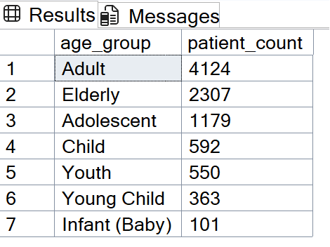

1. **AVG number of patients by Gender and Total wait time**

SELECT

patient_gender,

COUNT (patient_gender) as total_number_of_patient_by_gender,

AVG(patient_waittime) AS avg_waittime

FROM [Hospital ER]

GROUP BY patient_gender

ORDER BY avg_waittime DESC;

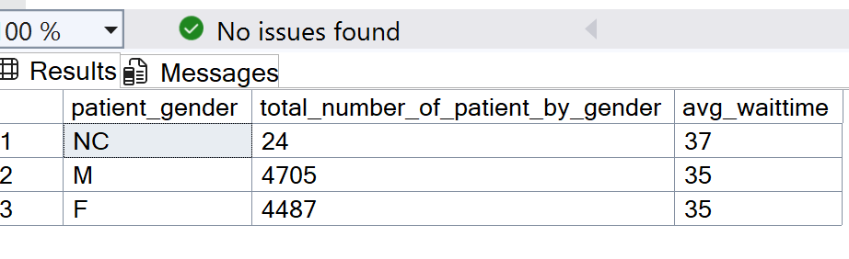

**6b. Total number of patients by Race and Total wait time**

SELECT

s,

COUNT (s) as total_number_of_patient_by_race,

SUM(patient_waittime) AS avg_waittime

FROM [Hospital ER]

GROUP BY s

ORDER BY avg_waittime DESC;

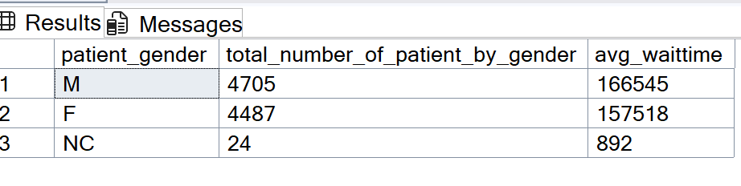

1. **Total number of patients by race and avg wait time**

SELECT

patient_gender,

AVG(patient_waittime) AS avg_waittime

FROM [Hospital ER]

GROUP BY patient_gender

ORDER BY avg_waittime DESC;

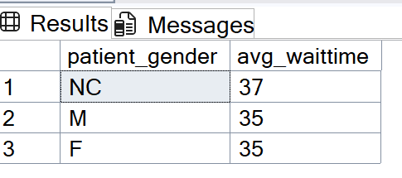

1. **Avg patient satisfactory score**

SELECT

(patient_gender) as patient_gender,

AVG (patient_sat_score) as avg_patient_satifactory_score

FROM [Hospital ER]

GROUP BY patient_gender

ORDER BY avg_patient_satifactory_score DESC;

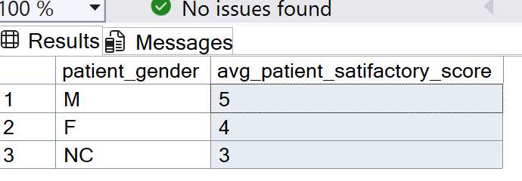

1. **patient Admission Rate**

SELECT

CAST(SUM(CASE WHEN patient_admin_flag = 1 THEN 1 ELSE 0 END) AS FLOAT)

/ COUNT(*) * 100 AS admission_rate_percent

FROM [Hospital ER];

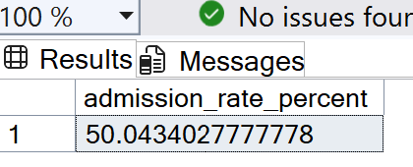

1. **Count Admissions vs. Discharges**

SELECT

patient_admin_flag,

COUNT(*) AS visit_count

FROM [Hospital ER]

GROUP BY patient_admin_flag;

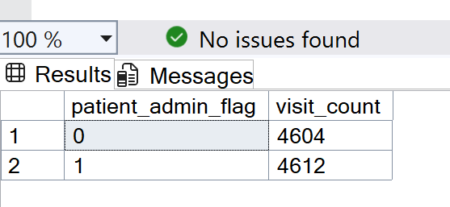

1. **Admitted vs. Not admitted BY Department_referral**

SELECT

department_referral,

SUM(CASE WHEN patient_admin_flag = 1 THEN 1 ELSE 0 END) AS admitted_count,

SUM(CASE WHEN patient_admin_flag = 0 THEN 1 ELSE 0 END) AS not_admitted_count,

COUNT(*) AS total_visits,

CAST(SUM(CASE WHEN patient_admin_flag = 1 THEN 1 ELSE 0 END) * 100.0 / COUNT(*) AS DECIMAL(5,2)) AS admission_rate_percent

FROM [Hospital ER]

GROUP BY department_referral

ORDER BY admission_rate_percent DESC;

